Sprint 5 BurnDown chart:

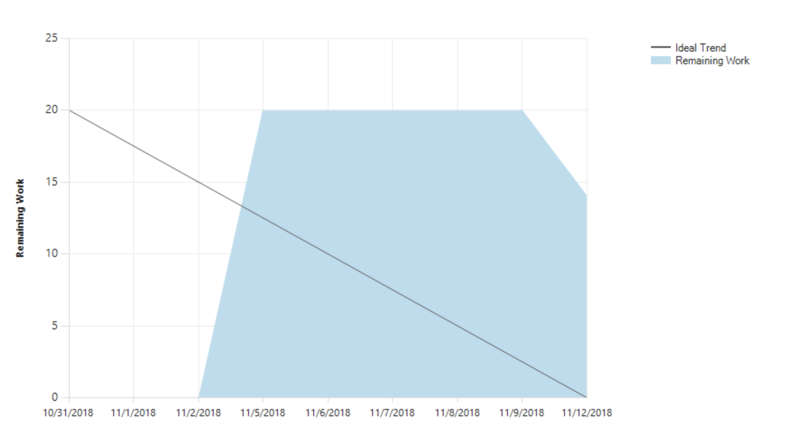

For this sprint, the burn down chart looks quite normal, everyone picks up its work and hope to finish them on time. So, for this time, it looks more normally. The line looks more like a consist going down chart. The Sprint 5 tasks is different from the former Sprints. It looks more detail and delicate than our previous work. In this case, we have more tasks than before work. But his time, still some of our group member forget to assign the name to the task, that cause the burn down chart does not look that consist. But overall, it looks good and normal.

The structure is still like, we spend several days to work on the feature so, make the line flat for a while, I think that is the most reason we did not make the line go like a shape edge.

In our future work, for sprint6, we would try our best to make looks better and better to go.